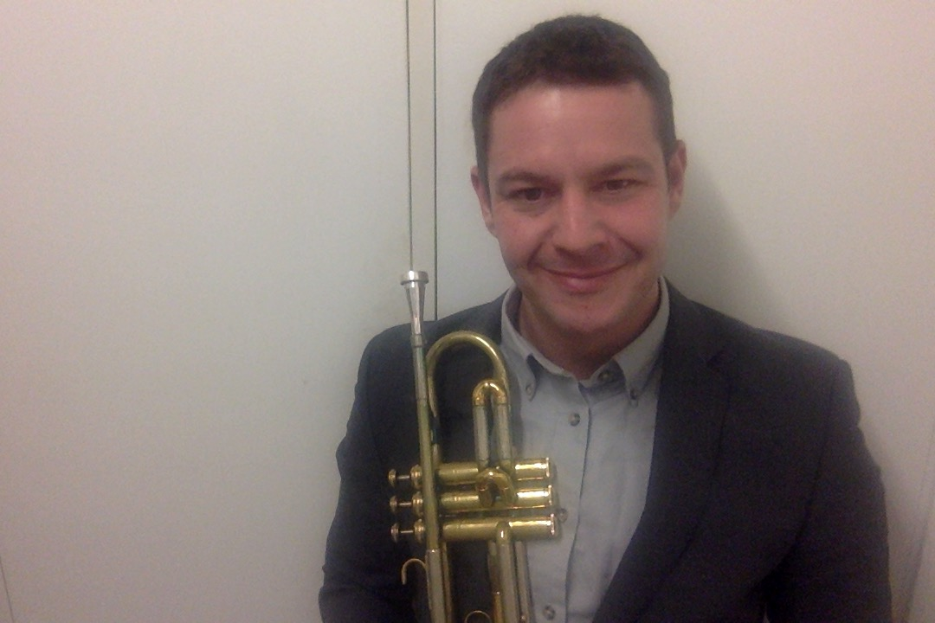
Details

Reuben Luca Christman

DOB - 31/03/84
Address - 3/250 Mill Point Rd South Perth
WWC – 818240
TRB - 32061966
Phone Number - 0408906150

Email – Reuben.Christman@education.wa.edu.au

Soundcloud –https://soundcloud.com/reubtube

Primary Music Teacher - 8 Years Experience
Secondary Music Teacher- 8 Years Experience
Peripatetic Brass Tutor - 12 Years Experience

Statement

It is my belief that the role of a great music teacher is to inspire students to perform at their very best capabilities in a safe and supportive classroom environment. My decision to undertake a teaching career is centred on my commitment to the arts. I consistently aim to use my performance experience as a tool for inspiring the students to believe in their own abilities. My teaching practice is driven by my personal passion for my subject area and the educational progress of my students. I am a vibrant, creative yet methodical practitioner, whom at all times expects the highest degree of respect from my students and likewise expects them to treat each other in a similar manner.
I stress the development of respectful and positive relationships with staff and students. This forms the core of my teaching practice. Empowering individuals with the responsibility of performance and seeing them achieve is personally a most joyous experience. I have learnt this can be achieved through demonstrating a consistently compassionate yet firm approach towards all students. Implementing effective instructional and behavioural strategies inspires the pursuit of creative knowledge in a safe and positive environment. That is, I believe being an excellent teacher.

Experience

February 2016 – Present
Bayswater Primary School, Perth, Western Australia

Music Teacher

- Foster a classroom music environment conducive to learning and promoting excellent student engagement
- Develop and implement daily and unit lesson plans for years PP to 6 classroom music students
- Actively participate in whole staff meetings
- Coordinate the school’s Junior and Senior Choirs
- Oversee extra curricular musical activities within the school
- Play multiple instruments for classroom music activities
- Assist in the development of the school’s four year strategic plan
- Participate in professional learning opportunities
- Manage the music budget
- Organise performances within and outside of the school

February 2016 – Present
St Marks Anglican Community College, Perth, Western Australia

Brass Tutor

- Develop basic to advanced skills of trumpet students from years 5 through to 12
- Assist in preparing the students for future school performances
- Develop excellent rapport with students, parents and colleagues

July 2015 - December 2015
International School of Lusaka, Lusaka, Zambia

Head of Arts/ High School Music Teacher

- Oversaw teaching programs in accordance to the International Baccalaureate, Primary Years, Middle Years and Diploma Programs
- Managed the ongoing development of the School’s Choir and Instrumental Music Program
- Fostered a classroom music environment conducive to learning and promotion of excellent student engagement
- Developed and implemented daily and unit lesson plans for years PP to 6 classroom music students
- Actively participated in whole school planning meetings
- Played multiple instruments for classroom music activities
- Assisted in the development of the school’s ten-year strategic plan.
- Ran a vibrant and successful arts program
- Participated in professional learning opportunities

January 2011 – June 2015
Edgewater Primary School, Edgewater, Western Australia

Music Teacher

- Collaborated with colleagues as an acting member of the behaviour management committee to produce academic and behaviour management.
- Actively gave input into the school’s ethics and values committee
- Developed specific and challenging curriculum materials for talented and gifted students using electronic whiteboards, the internet, library sources and independent instrumental music programs
- Taught several talented and gifted children who went on to study at Churchlands, Perth Modern and John Curtain College of the Arts
- Participated in parent conferences
- Managed the school’s music budget
- Actively participated in meetings with the aim of whole school planning
- Managed the ongoing development of the School’s Choir and Instrumental Music Program
- Operated the school’s PA system for assemblies and other special performances such as fetes and sports carnivals
- Developed and implemented daily and unit lesson plans for years K to 7 classroom music students
- Participated in professional learning opportunities

- Played the piano for classroom music activities

January 2011- September 2013
Woodthorpe School, Willetton, Western Australia

Music Coordinator
- Fostered a classroom music environment conducive to learning and promoting excellent student engagement
- Conducted the years 5 and 6 concert bands, high school jazz big band and the primary/secondary combined choir
- Played the piano for classroom music activities
- Coordinated all performances
- Implemented planning on a whole school level whilst considering the implications of the new Australian Curriculum
- Oversaw the lessons of all instrumental music students conducted by their peripatetic tutors
- Managed the school’s music budget
- Managed the payroll of the school’s peripatetic teachers
- Administered testing with the intention of analyzing and tracking classroom music performance
- Managed the school’s music instrument loans system
- Conducted parent conferences
- Developed an excellent rapport with students and colleagues
- Oversaw the school’s flute octet and percussion ensemble
- Developed and implemented daily and unit lesson plans for years 3 and 4 classroom music students
- Participated in faculty and parent conferences

January 2010 – December 2010
Dongara District High School, Dongara, Western Australia

Music Teacher
Physical Education Teacher

- Filled the role as music teacher for years 1 to 8
- Filled the role as physical education teacher for years 1 to 4
- Developed excellent rapport with students, parents and colleagues
- Maintained appropriate student behaviour and completed pastoral duties such as the completion and submission of absentee rolls
- Coordinated school performance practices and concerts
- Played the piano for classroom music activities
- Fostered a classroom music and physical education environment conducive to learning and promoting excellent student engagement
- Operated the school’s PA system for assemblies and other special occasions
- Assisted in the production of school performances
- Coordinated the school’s Junior Choir and High School Rock Band
- Participated in faculty and parent conferences

August 2009 - December 2009 Dalwallinu District High School, Dalwallinu, Western Australia

General Teacher

- Maintained appropriate student behaviour and completed pastoral duties such as the completion and submission of absentee rolls
- Delivered lessons to students of the ages of years 8 to 10 on the subjects of Music, Information, Communication and Technology, Science, Design and Technology and English
- Assisted with school performance practice sessions including leading the school’s rock band
- Supervised students from kindergarten to year 10 during recess time
- Assisted in the production of school performances
- Oversaw the design and production of the school’s year book
- Participated in faculty and parent conferences
- Developed excellent rapport with students, parents and colleagues

March 2006 – May 2007,
St Norbert’s College, Queens Park, Western Australia

Brass Tutor

- Maintained appropriate student behaviour and completed pastoral duties such as the completion and submission of absentee rolls
- Developed basic to advanced skills of brass students from years 8 through to 10
- Assisted in preparing the students for future school performances
- Participated in parent conferences
- Developed excellent rapport with students, parents and colleagues

May 2006 - Present
Private Brass and Keyboard Tutor

Develop student’s skills in playing brass and keyboard instruments

Qualifications

2010
Accredited ‘Drumbeat’ Coordinator (Djembe Drum Based Program)
Accredited completion of the Western Australian Department of Education’s
Course -Classroom Management Strategies.

2008
Diploma of Education
Secondary School Music Specialist Teaching
University of Western Australia, Crawley, W.A.

2007
Bachelor of Musical Arts
University of Western Australia, Crawley, W.A.

2010
Accredited ‘Drumbeat’ Coordinator (Djembe Drum Based Program)
Accredited completion of the Western Australian Department of Education’s
Course -Classroom Management Strategies.

Achievements

2017 – Conducted the Bayswater Primary School Choir at the Perth Concert Hall
- Formed the ‘Reuben Christman Trio’ and ‘Reuben Christman Quintet’(s)
- Finalist in the ‘Earplay’ Composition Competition.

2016- Conducted the Bayswater Primary Choir at the Perth Arena
- Toured Internationally with Latin group ‘Orchestra Yambebue’

2014 – Composed the original score for The University of Western Australia's Scitech planetarium exhibition.

2013 - Conducted the Edgewater Primary School Choir at the Western Australian Primary Principal’s Conference

2012 - Conducted the Edgewater Primary School Choir as they performed on the annual Channel 9 Christmas Special

– As member of the unique Dub Reggae group ‘The Weapon Is Sound’ and Soul Band ‘The Houston’s’. Performed 100+ concerts throughout the year, excluding other independent shows

2009 – Awarded Best Album of the Year, Urban Music, West Australian Music Industry Awards WAMI

2008- With popular Perth band ‘The Typhoons’ performed at numerous major music festivals including, Parklife, Future Music, Breakfest and Summer Dayze.
- Nominated best Urban Act, West Australian Music Industry Awards WAMI

2007 – As a member of the popular Perth band ‘The Typhoons’ awarded Best Live Act in Western Australia, Perth Dance Music Awards

2001 – Awarded the Highest Achieving Music Student at Eastern Hills Senior High School

2001 – As a trumpet player, performed my own arrangements with the iconic rock band “Gangagang” at Western Australia’s celebration of the Australia Day ‘Skyworks’ with an estimated audience of 100000 people

1999 – Present- Hold the title of ‘Bugler’ for ANZAC Day and Other Returned Services League performances as a service to Australian Army.

References

Mrs Pamela Grubb – Acting Director of Music, St Marks Anglican Community College, Hillarys, Western Australia
Ph – 9403 1300
Email – pgrubb@stmarks.wa.edu.au

Mr Neil Hodgkinson – Primary Coordinator, Woodthorpe School, Willetton, Western Australia
Ph – 0407476870
Email – Neil.Hodgkinson@education.wa.edu.au

Mrs Julie Tombs– Principal, Edgewater Primary School, Edgewater, Western Australia
Ph - 94054007
Email – julie.tombs@education.wa.edu.au

Mr Terry Butt – Senior Teacher, Edgewater Primary School, Edgewater, Western Australia
Ph - 0448 356 749
Email – terry.butt@education.wa.edu.au

