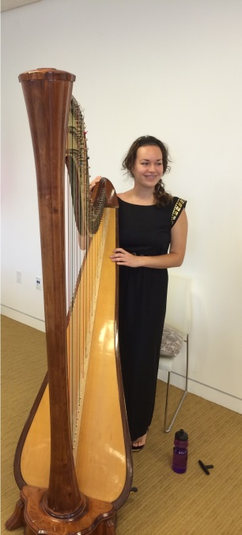

CURRICULUM VITAE

Name: Ana Marija FRANC

Date birth: May 24th, 1989

Birth country: Serbia

Mobile phone: +381 64 252 48 77

E-mail address: ana.marija.franc@gmail.com

Youtube channell: Ana Marija Franc

Education: Primary school: harp, violin and singing (finished in 2004)
High school: harp (finished in 2008)
Masters in harp performance (finished in 2013)
Bible school and missionary work in Norway(finished in 2015)

Master classes for harp and singing(during studying):
Elizabet Fontan Binos (France), Jana Bouskova (Chech Republic),
Catrin Finch (Wales), Jon Ivan Roncea (Romania), Andrea Stern (USA),
Leila Urmanova (Russia), Angela Madjarova (Bulgaria) Zoraida Avila Pena (Spain),
Silke Aichhorn (Germany), Isabela Moretti(France).
Summer Academy for singing in Hungary(Andras Farkas).
National and international awards:
- 1st prize for harp(Serbia 2006, Slovenia 2007)
- 2nd prize for harp(Bosna 2006)
- 3rd prize for singing (Serbia, 2006)
- winner at harp competition(Slovenia 2010)
- student of generation in high school (2008)
- one of the best of 1000 students in generation 2012/2013
(97% during studying)
Harp recitals and orchestra: Serbia, Croatia, Hungary, Arizona, California, Germany, Sweden, Norway.
Member of youth philharmonic orchestra(2011)
Languages: Serbian (mother language), English (advanced), German(beginner),
Hebrew(beginner)
Harp CDs: 1.“Amazing grace”, 2.“There is a truly blessed land”, 3.”In Christ alone my
Hope is found”, and couple of Christian orchestra CDs.
Volonteer work: Harp ministry (May 2013 – February 2014) - visiting homes for:
Blind people, Elderly homes, Orphanages, churches, poor families.
Volonteered for 10 years at IntraVarsity student Christian organization(Serbia).
Volonteered at Nick Vujicic event in Serbia (Serbia-Belgrade 2012, 2017)
Volonteered with children for 2 months. (Serbia-Zemun 2013)
Working experience: Music theory teacher at primary school in Borča (Serbia 2015)
Music theory and piano teacher at British Internation School (Serbia 2015)
Harp teacher in Music School of Pančevo (Serbia 2016-2017)
Playing harp at various events: 1st Balkan prayer breakfast in Serbia (2016)
The wedding of the world No.1 tennis player Novak Djokovic

Currently: I am working on my first solo album where I will be playing the harp
and piano as well as singing my lyrics.
I am writing a book.

